Name: Date:

DATE DUE: 12/19/13 Social Studies
Chapter 4 - The 13 Original English Colonies

Colonial Brochure – Organizer

Task: Create a marketing brochure that would attract settlers to the east coast of North America in the late 1600’s or early 1700’s.

Process:

- Choose a Region – Pick one of the three regions below for your brochure. Put a checkmark in the box of the region you choose.

❑ New England Colonies  Middle Colonies  Southern Colonies

- Create a Map - Use the map provided in this packet or find one on the Internet to highlight/shade your selected colonial region. Be sure to label each of the colonies in your region and write in the name of its founder/leader.

- Gather Facts – To attract settlers to your region, your brochure will need to include information about the resources, environment, and opportunities there. Look for information in your textbook, on-line and in the library. Fill in the blanks for each section below with the information you collect:

  - Geography – Some important landforms and bodies of water in the region are:

____________________________________________________________________________________________________________________________________________________________________________________________________________________________________________________________________________________________________________________________________________________________________________________________________________________________________________________________________________________

  - Climate – The climate in the region is:

________________________________________________________________________________________________________________________________________________________________________________________________________________________________________________________________________________________________________________________

  - Natural Resources – The natural resources found in the region are:

________________________________________________________________________________________________________________________________________________________________________________________________________________________________________________________________________________________________________________________

  - People – The Native American groups in the region include:

________________________________________________________________________________________________________________________________________________________________________________________________________________________________________________________________________________________________________________________

Settlers in the region have emigrated from these countries and/or geographic areas:

________________________________________________________________________________________________________________________________________________________________________________________________________________________________________________________________________________________________________________________

  - Government – The system of government in the region is:

________________________________________________________________________________________________________________________________________________________________________________________________________________________________________________________________________________________________________________________

  - Economy/Industry – The different ways in which people in the region make/earn a living are:

________________________________________________________________________________________________________________________________________________________________________________________________________________________________________________________________________________________________________________________

  - Religion – The religious traditions/beliefs of the colonists in this region include:

________________________________________________________________________________________________________________________________________________________________________________________________________________________________________________________________________________________________________________________

  - Daily Life – Some interesting aspects of daily life include:

________________________________________________________________________________________________________________________________________________________________________________________________________________________________________________________________________________________________________________________

- Write Descriptions – Write a one or two paragraph description for each of the above aspects of your region. Remember, the purpose of the brochure is to convince people of the late 1600’s and early 1700’s to leave their homeland and come to your region. Therefore, as you describe each aspect of the region, make sure you include how it is a benefit for the settlers there (**Be creative here, highlight the positives and downplay the negatives – advertise!).

Check off each as you complete it:

❑ Paragraph on geography completed!
❑ Paragraph on climate completed!
❑ Paragraph on natural resources completed!
❑ Paragraph on people completed!
❑ Paragraph on government completed!
❑ Paragraph on economy completed!
❑ Paragraph on religion completed!
❑ Paragraph on daily life completed!

❑ All sections have been proofread, edited, and revised!

5. Add Artwork – Create/locate bold, strong images that will make settlers want to come to the region. Include at least one image for each paragraph above. [Note: Images may be hand-made, clip art, taken from magazines, or etc…]

Check off when completed:

❑ Images added.

- Assemble the Brochure – Design a page/section for each aspect of your region. Give each page/section a title, such as “Geography” or “Daily Life on a Plantation”. Then arrange and paste (or cut/paste on PC/Mac) in the description & image(s) for each aspect of the region on the appropriate page/section. You must also include your map and a cover page. You may bind the brochure however you see fit (i.e., staples, report holder, etc…).

Check off when completed:

  - Brochure completed.

7. Rubric – Complete the evaluation on the next page using a blue or black pen and turn it in with your brochure.

Check off when completed:

  - Evaluation completed.

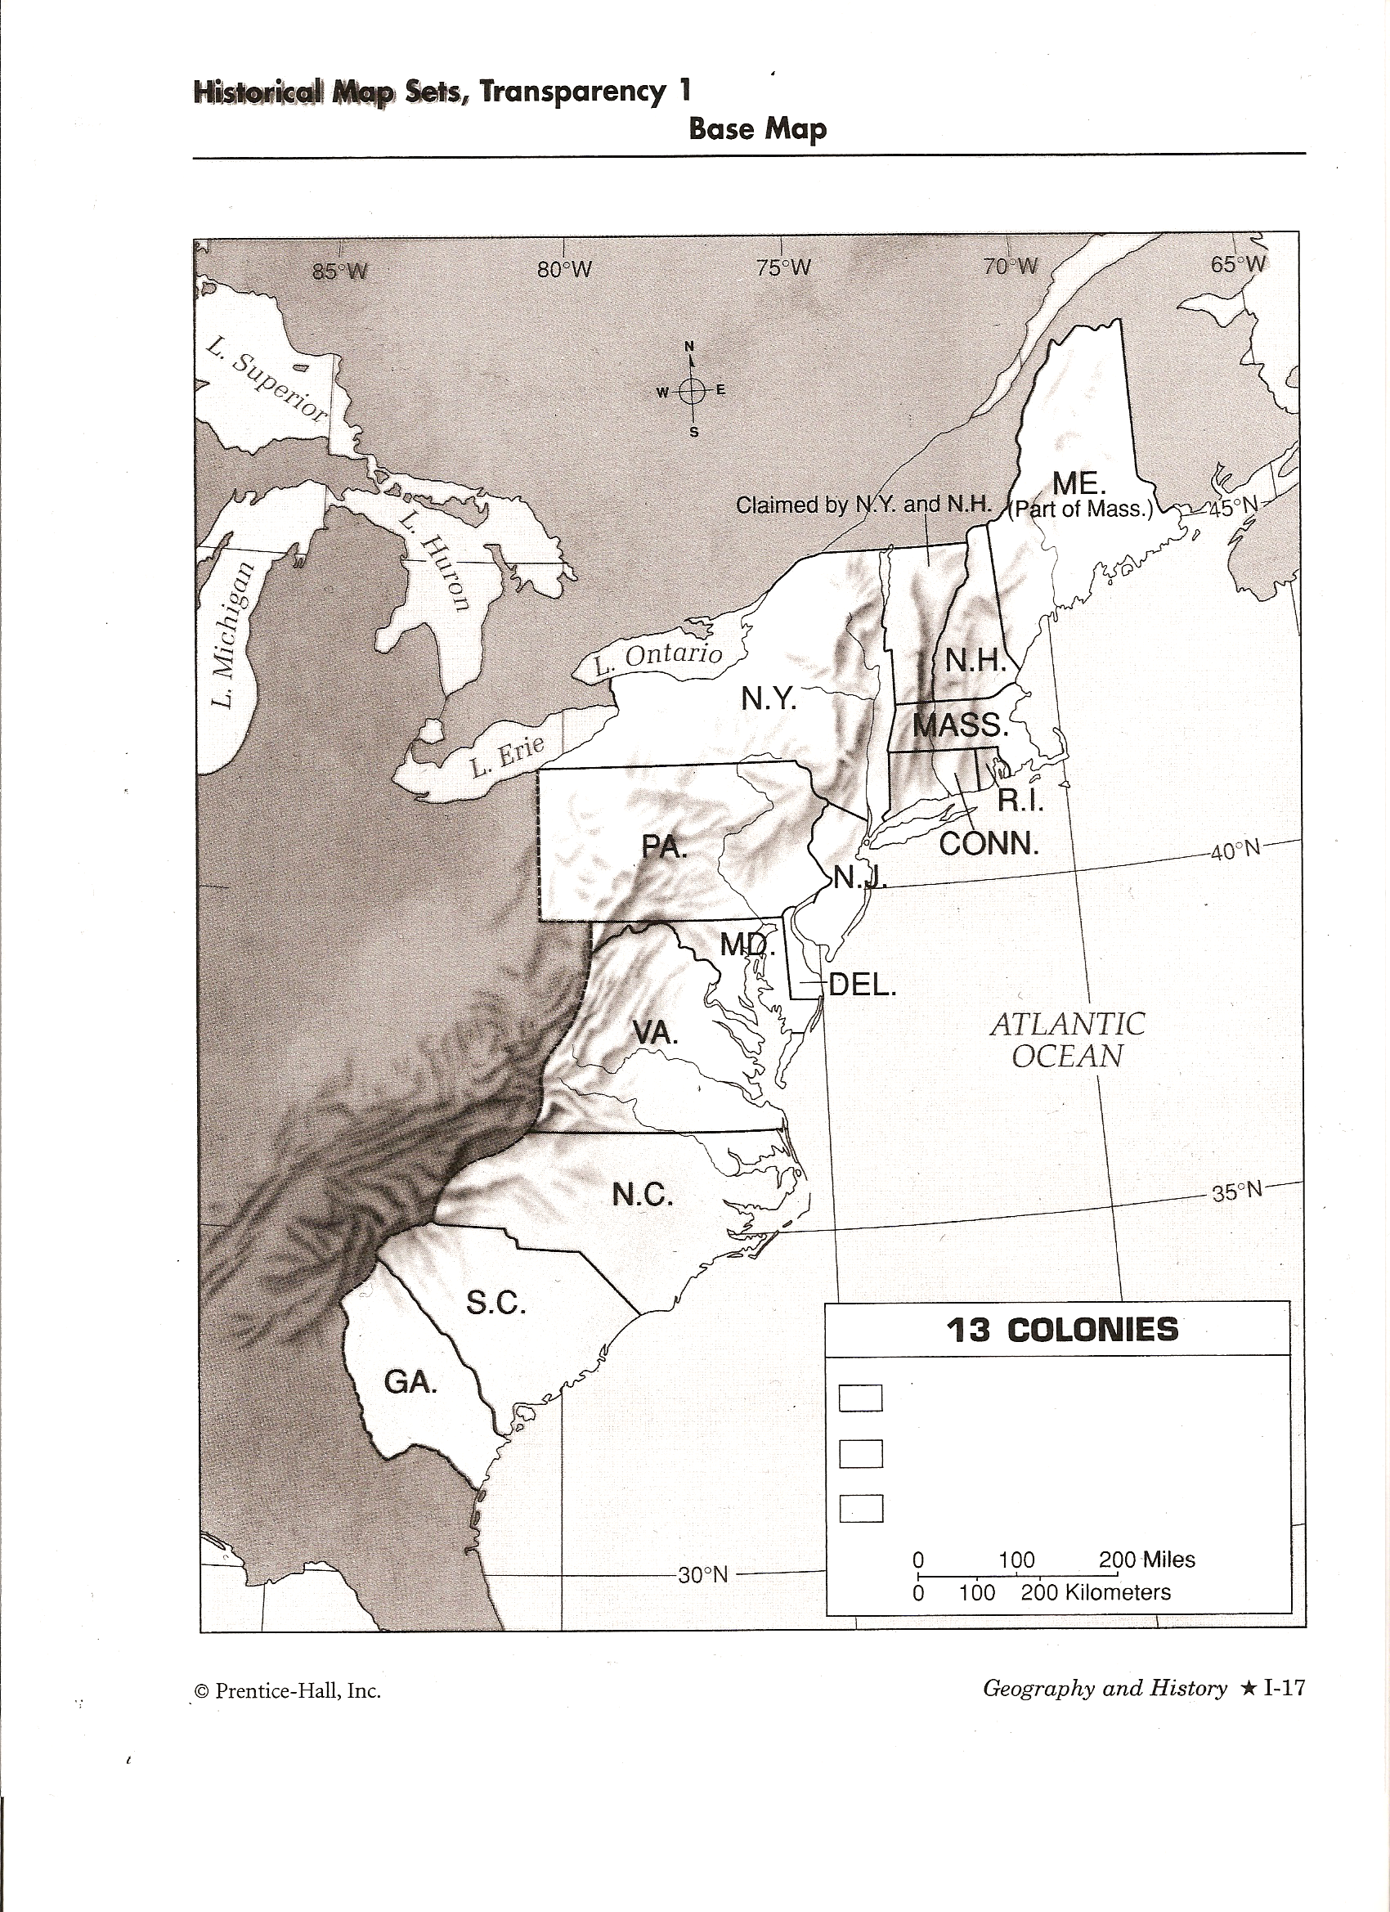

Name: Class: File #: Date:

Social Studies
Chapter 4 - The 13 Original English Colonies

Colonial Brochure – Evaluation
For each item listed below, circle the number that best describes your performance using a blue/black pen:
0 = Not completed 1 = Poor 2 = Fair 3 = Good 4 = Very Good 5 = Excellent

1. Map: Overall appearance 0 1 2 3 4 5

Region highlighted/shaded 0 1 2 3 4 5

Colonies labeled 0 1 2 3 4 5

Founder/Leader included 0 1 2 3 4 5

2. Writing: Overall quality of writing 0 1 2 3 4 5

Geography 0 1 2 3 4 5

Climate 0 1 2 3 4 5

Natural Resources 0 1 2 3 4 5

People (Native & Immigrants) 0 1 2 3 4 5

Government 0 1 2 3 4 5

Economy 0 1 2 3 4 5

Religion 0 1 2 3 4 5

Daily Life 0 1 2 3 4 5

3. Images: Overall quality of the images 0 1 2 3 4 5

Included one image for each aspect above 0 1 2 3 4 5

4. Creativity: 0 1 2 3 4 5

5. Other: Cover page 0 1 2 3 4 5

Name on Cover 0 1 2 3 4 5

Class & Number on Cover 0 1 2 3 4 5

Neatness 0 1 2 3 4 5

Total Points Earned: _______________

After you have completed the evaluation above, write down the grade you think you have earned on the line below marked “Student”.

Grade - Student : ______________ Teacher:______________

